Magnetic field configurations at solar flare sites above active region AR 10365 from MHD simulation results

А.I. Podgorny¹, I.M. Podgorny²

¹Lebedev Physical Institute RAS, Moscow, Russia, podgorny@lebedev.ru
²Institute of Astronomy RAS, Moscow, Russia

Abstract. The fast release of the magnetic energy of the current sheet leads to the observed manifestations of the flare, which are explained by the electrodynamic model of the flare proposed by I. M. Podgorny. The study of the solar flare mechanism by the magnetohydrodynamic (MHD) simulation in the solar corona above the real active region is continued. In order to be able to study the mechanism of a solar flare, it is necessary to begin calculations several days before the flare, when the magnetic energy for a solar flare has not yet accumulated in the corona. Two variants of calculation were carried out for relatively high magnetic and ordinary viscosities (Re_{m}=3×10⁴, Re=10⁴) and for relatively low viscosities (Re_{m}=10⁹, Re=10⁷). For MHD simulations with relatively high viscosities, a property was found that is possessed only by those current density maxima that are located in the bright region of pre-flare radio emission at a frequency of 17 GHz.

Introduction
The primordial release of magnetic energy during solar flares occurs in the solar corona above the active region at altitudes of 15 - 70 Mm, which is proven by both direct observations of thermal X-ray emission from flares on the limb [1] and analysis of flare observation data [2-4]. The same flare heights provide the results of the MHD simulation in the corona above the active region, continued in this work.
The appearance of flares in the corona is explained by the mechanism of S.I. Syrovatsky [5], according to which the flare energy accumulates in the magnetic field of the current sheet. A current sheet is formed in the vicinity of a singular magnetic field line under the influence of disturbances propagating from the solar surface. During the quasi-stationary evolution of the current sheet, in which the total mass of the sheet plasma decreases due to its fast outflow from the sheet under the influence of magnetic tension, the current sheet transferee into an unstable state (see, for example, [6]). The flare release of the magnetic field energy of the current sheet as a result of instability leads to the observed manifestations of the flare, which are explained by the electrodynamical model of the solar flare proposed by I. M. Podgorny [7]. Hard beam X-ray radiation on the solar surface appears due to the deceleration in the lower dense layers of the solar atmosphere of electrons accelerated in field-aligned currents on magnetic lines exiting from the current sheet. Field-aligned currents belong to the electrical circuit, which is created by the Hall electric field in the current sheet. The model was developed based on the results of observations and numerical magnetohydrodynamics (MHD) simulations and uses analogies with the substorm electrodynamic model proposed earlier by its author [8].
Since it is impossible to determine the configuration of the magnetic field in the corona from observations, to study the physical mechanism of a solar flare it is necessary to carry out MHD simulation of the flare situation in the solar corona fbove the real active region. MHD simulation is continued in this work; it has been carried out for many years under conditions that are permanently being modernized in order to bring them as close as possible to real conditions in the corona [9-16]. When setting up the MHD simulation problem, no assumptions were made about the mechanism of the solar flare; all conditions were taken from observations. The magnetic field observed at the solar surface is used to set conditions at the photospheric boundary. In order to study the mechanism of solar flares, calculations must begin several days before the appearance of flares, when energy for the flare has not yet accumulated in the magnetic field of the corona.

Setting of the problem, method of solving the problem, selection of parameters
MHD simulation is carried out above the active region of AR 10365. The computational domain in the corona is a rectangular parallelepiped (0≤х≤1, 0≤y≤0.3, 0≤z≤1) (the length unit was chosen L₀=4×10¹⁰ cm). The lower boundary of the computational domain y=0 (XZ) is located on the surface of the Sun (photosphere) and contains the active region; the Y axis is directed from the Sun perpendicular to the photosphere. The X axis is directed from east to west, and the Z axis is from north to south. A typical magnetic-field strength in the active region, B₀ = 300 G, was used as the unit of the magnetic field. The units of the plasma density and temperature were taken to be their typical values in the corona above the active region, n₀=ρ₀/m_{i}=10⁸ cm⁻³, T₀=10⁶ ºK, which were assumed to be initially constant (m_{i} = 1.67×10⁻²⁴ g is ion mass). The units of plasma velocity and time are, respectively, the Alfvén velocity and Alfvén time $V_{0}=V_{A}={B_{0}}/{\sqrt{4{\text{πρ}}_{0}}}$ = 0.65×10¹⁰ cm/s, t₀=L₀/V₀= 6.1 s. The unit of current density in the CGS system j₀ = cB₀/4πL₀ is j₀ = 17.9 in the system CGS, which corresponds to 5.97×10⁻⁹ A/cm².

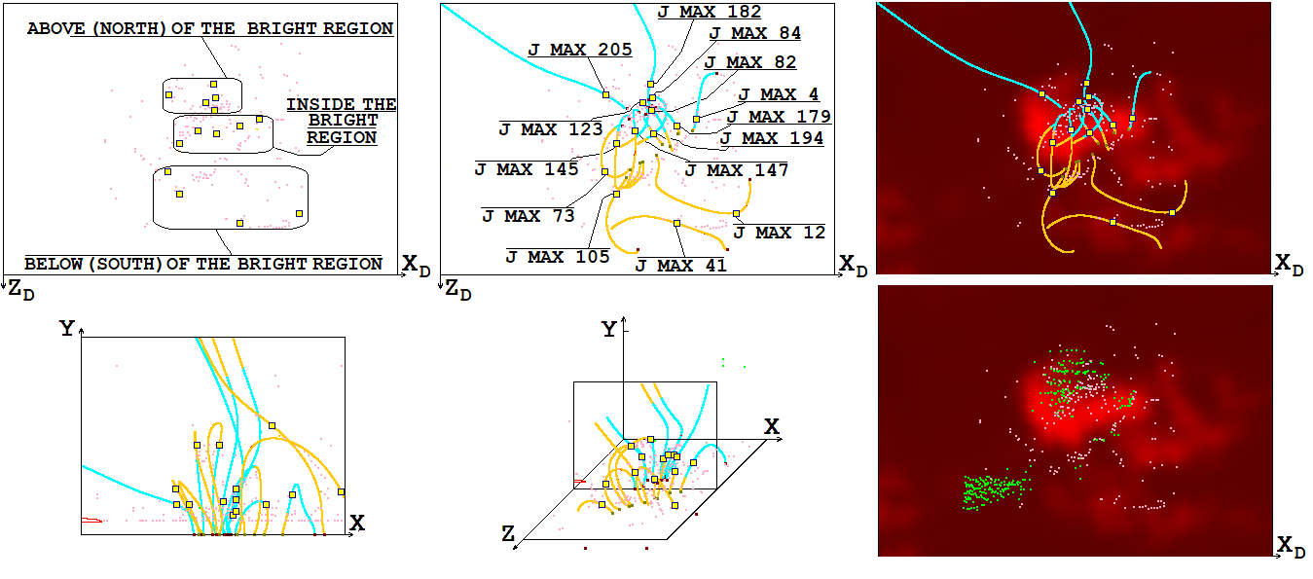
Figure 1. Comparison of the magnetic field configuration and the positions of the current density maxima with the distribution of radio emission intensity at a frequency of 17 GHz on May 26, 2003 at 02:32:05 three hours before the M 1.9 flare for calculation with relatively high viscosities (Re_{m}=3×10⁴, Re=10⁴). The positions of the current density maxima are shown as violet points. The magnetic field configuration is presented by magnetic lines which pass through selected current density maxima with numbers 4, 12, 41, 73, 82, 84, 105, 123, 147, 145, 179, 182, 194, 205. 3D magnetic lines in the computational domain and their projections onto the picture plain (which is perpendicular to line of sight direction) and onto the central plane of computation domain (this plane is perpendicular to solar surface and parallel to solar equator) are shown. Magnetic lines located in front of the central plane of the computational domain (z=0.5) are indicated in light brown, and magnetic lines located behind the central plane are indicated in light cyan. In the lower right corner, the current density maxima for calculations with high viscosities (Re_{m}=3×10⁴, Re=10⁴, violet dots) and the current density maxima for calculations with low viscosities (Re_{m}=10⁹, Re=10⁷, green dots) are superimposed on the distribution of radio emission intensity at a frequency of 17 GHz.

For the numerical solution, an upwind, absolutely implicit finite-difference scheme was developed which is conservative with respect to the magnetic flux [13, 17]. The methods were applied with the aim of constructing a scheme that remains stable for the maximum possible time step. The scheme was realized in the computer program PERESVET. The simulations were carried out by means of parallel computing threads on graphics cards using CUDA technology [14]. For low magnetic and usual viscosities numerical instabilities arise near the boundary of the computational domain, for the stabilization of which methods have been developed [12, 15].
The configuration of the magnetic field obtained by MHD simulation is so complex that it is impossible to determine the positions of singular lines and the current sheets appearing near them from it. For this purpose, a graphical search system of flare positions has been developed [9, 10]. The system is based on the search for current density maxima, which are reached in the middle of the current sheets. The current density maxima are located on the singular lines of the magnetic field.
To select dimensionless parameters the principle of limited simulation [18] was used, according to which much larger or much smaller unit, dimensionless parameters remain much larger or smaller than unit when simulated without their exact preservation. The real values of the magnetic and ordinary Reynolds numbers in the solar corona are Re_{m}= L₀V₀/ν_{m} = 2×10¹⁶, Re= 10⁴. Two variants of calculation were carried out for relatively high magnetic and ordinary viscosities (Re_{m}=3×10⁴, Re=10⁴) and for relatively low viscosities (Re_{m}=10⁹, Re=10⁷). Simulation for each variant has its advantages and disadvantages. In the first variant, numerical instabilities practically did not arise, since they were effectively stabilized at high viscosities. At low viscosities, the disturbance propagating from the solar surface is not suppressed, so that magnetic energy for a solar flare can accumulate in the solar corona. An idea of the behavior of the solution and processes near singular magnetic field lines in a real situation is formed by comparing the solutions obtained for these two sets of viscosities.
For both variants, the magnetic and ordinary Reynolds numbers are Re_{m}, Re >> 1, in this sense the principle of limited simulation [18] is fulfilled. It should be noted that the Reynolds numbers Re_{m} and Re reflect the predominance of transfer with the Alfven velocity, which is chosen as a dimensionless unit of velocity, over diffusion spreading. In the chosen system of dimensionless units, these Reynolds numbers are actually the inverse of the dimensionless viscosity values.

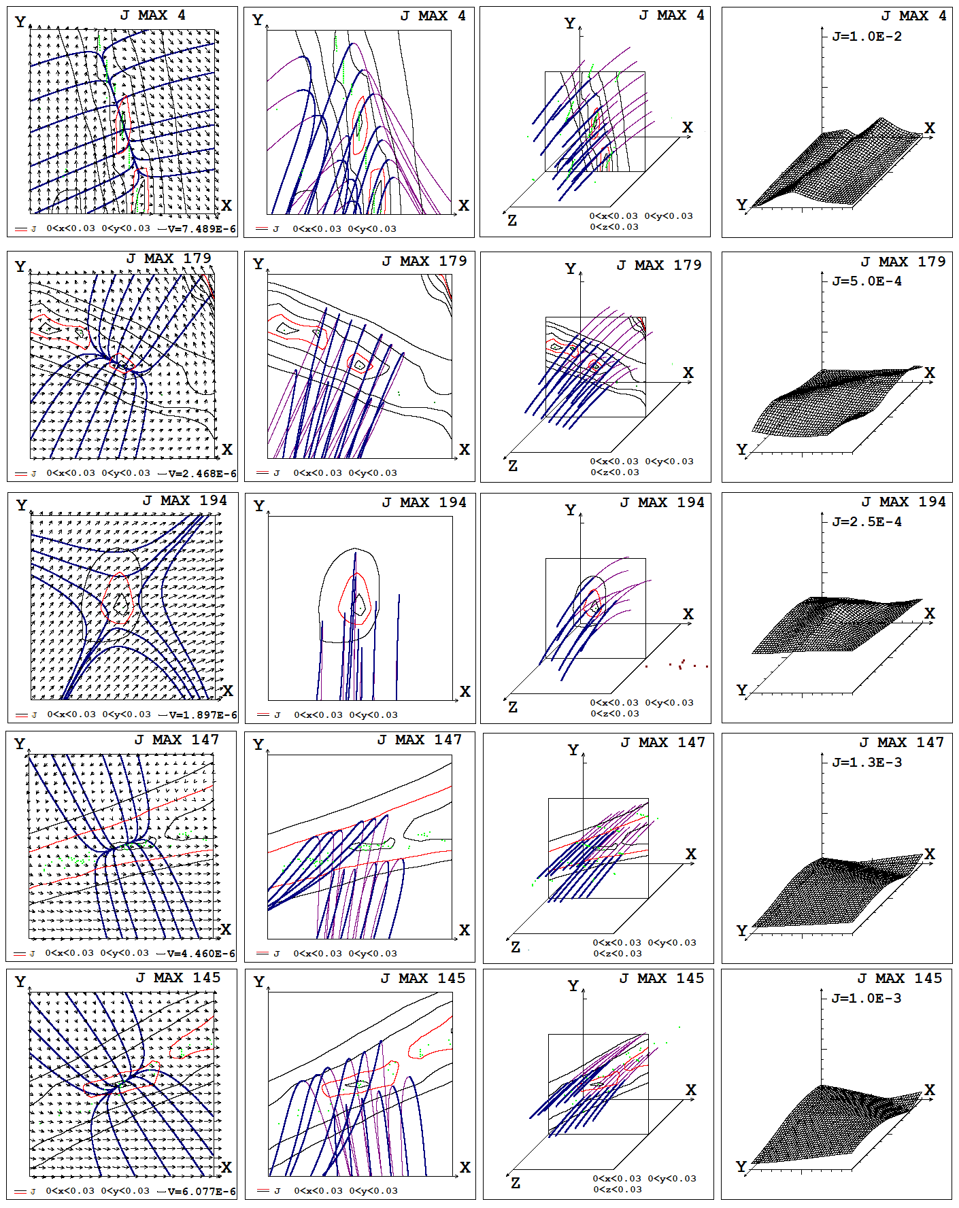
Figure 2. The configurations of the magnetic field, plasma flow velocity, and current density distributions near the selected 4th, 179th, 194th, 147th and 145th current density maxima on May 26, 2003 at 02:32:05 for calculation with relatively high viscosities (Re_{m}=3×10⁴, Re=10⁴) are presented (these maxima are located in the bright region of pre-flare radio emission). The configurations are shown by plane magnetic lines which are tangential to projections of magnetic vectors on the plane of configuration (this plane is perpendicular to singular line on which the current density maximum is situated; in this plane the configuration of current sheet is most distinctly pronounced), by projections of magnetic lines on the plane of configuration, and by 3D magnetic lines. Magnetic lines located in front of the plane of configuration are shown as bold blue lines, and magnetic lines located behind the plane of configuration are shown as thin brown lines. Lines of equal current density are shown as thin blue lines; one of them, apparently the most representative, is shown as thin red line. The scales of length, velocity and current density are presented in dimensionless units.
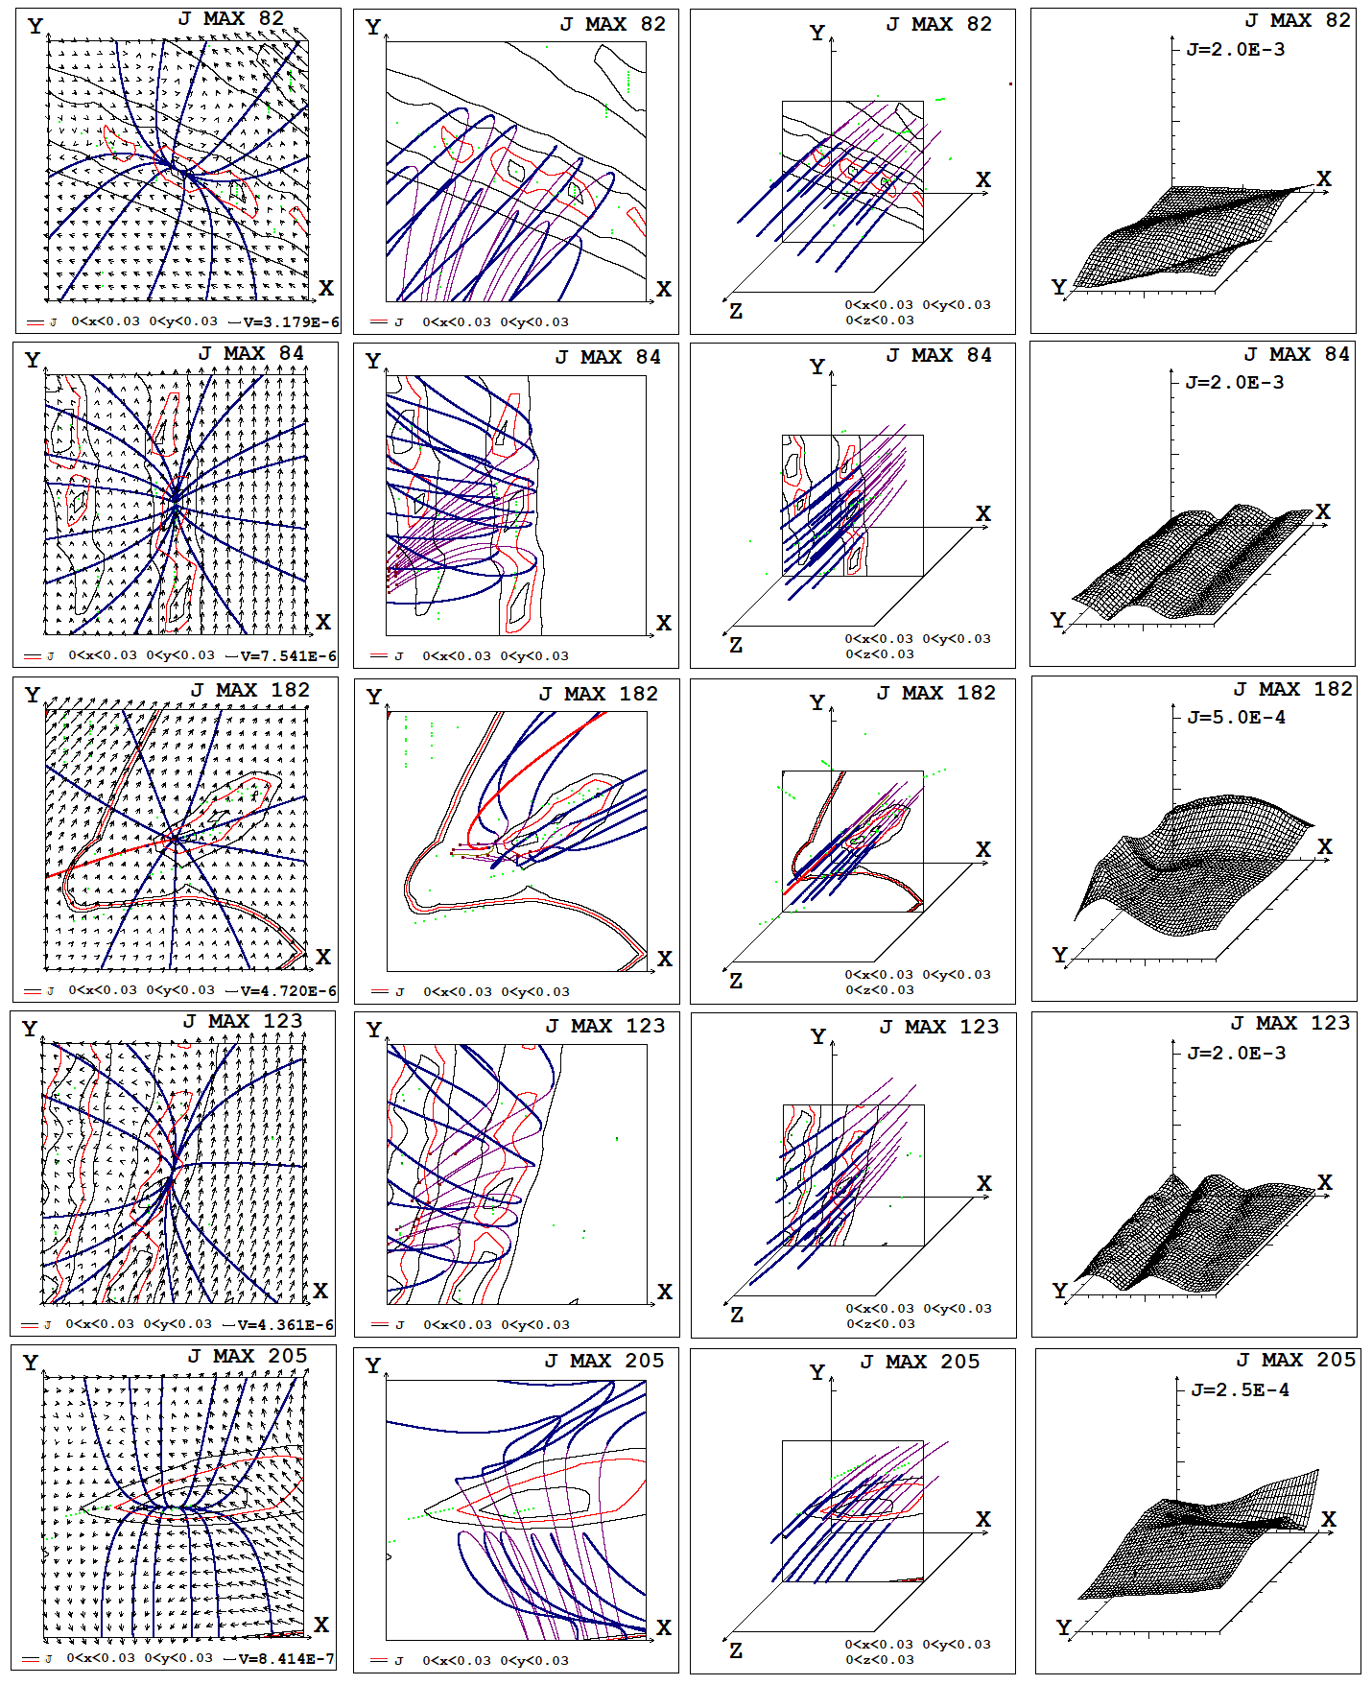
Figure 3. Configurations of the magnetic field, plasma flow velocity and current density distribution, near the selected 82nd, 84th, 182nd, 123rd and 205th current density maxima on May 26, 2003 at 02:32:05 for calculations at relatively high viscosities (Re_{m}=3×10⁴, Re=10⁴). These maxima are located above the bright region of pre-flare radio emission (to the North). Graphical representations are similar to those shown in Figure 2.

Results of MHD simulation
Figures 1 - 5 present the results of MHD simulation and their comparison with observations of radio emission at a frequency of 17 GHz in the active region of AO 10365, obtained with the Nobeyama radioheliograph. The results are presented at 02:32:05 on May 6, 2003, three hours before the M 1.9 flare. At this moment, the energy for the flare is accumulated in the magnetic field of the solar corona and the plasma is heated by the currents that create this field. Plasma heated to 6-7 MK causes pre-flare radiation, which can be used to determine the location where the flare will occur in the future. During a flare, the temperature of the plasma in the corona in the flare region increases to several tens of degrees, which leads to flare radiation. The results obtained show a similar arrangement of possible flare positions found from the results of MHD simulations, compared to regions of bright pre-flare and flare emission on the solar disk at various moments before and during the flare. However, to what extent the results obtained are typical for other time moments remains to be determined by more detailed comparison of the results of MHD simulations with observations.
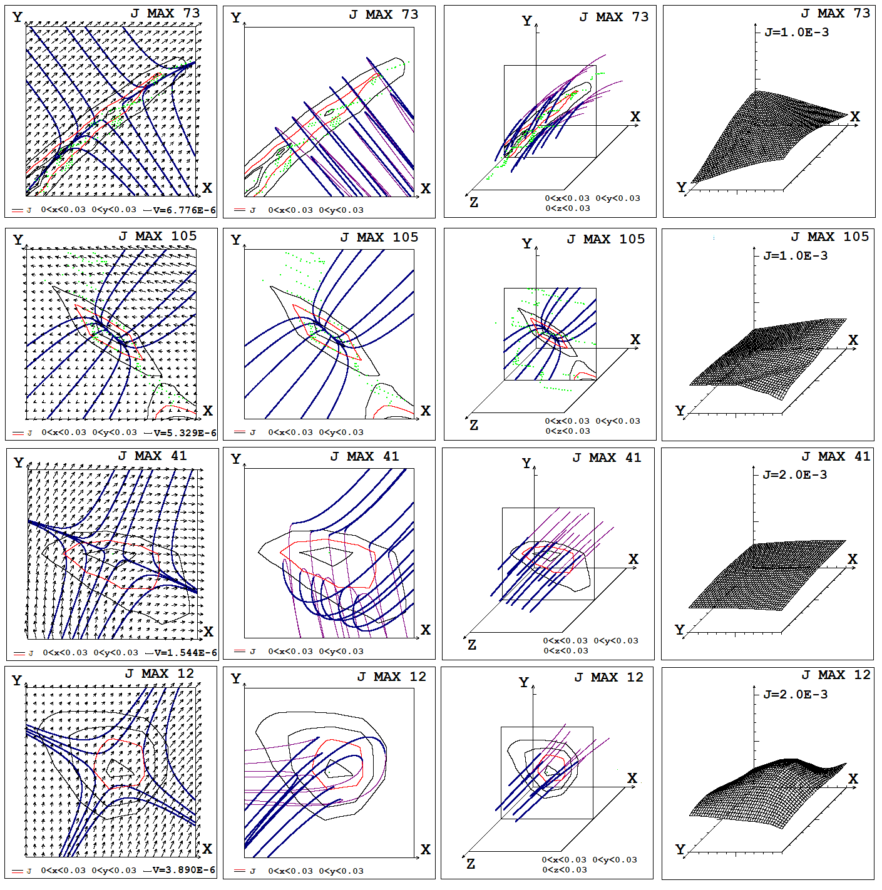
Figure 4. Configurations of the magnetic field, plasma flow velocity and current density distribution, near the selected 12th, 41st, 105th, and 73rd current density maxima on May 26, 2003 at 02:32:05 for calculations at relatively high viscosities (Re_{m}=3×10⁴, Re=10⁴). These maxima are located under the bright region of pre-flare radio emission (to the South). Graphical representations are similar to those shown in Figure 2.

Figure 1 shows the location of the current density maxima at the time of 02:32:05 on May 6, 2003 for the first calculation variant with relatively high viscosities (Re_{m}=3×10⁴, Re=10⁴). The magnetic field configuration is represented by magnetic lines passing through the selected 14 maxima, indicated by yellow squares, the remaining current density maxima are indicated by violet dots. Superimposed on the configuration of the magnetic field with the positions of the current density maxima in the picture plane (perpendicular to the line of sight) is the distribution of radio emission intensity at a frequency of 17 GHz, represented by shades of red of varying brightness. In the bright region of high-intensity radio emission there are selected current density maxima with numbers 4, 179, 194, 147 and 145 (all maxima are numbered in descending order of current density in them). Above the bright emission region (to the north) are maxima numbered 82, 84, 182, 123 and 205, and below the bright emission region (to the south) are maxima numbered 12, 41, 105 and 73. The lower right corner of Figure 1 shows the location of the current density maxima for calculation variants with high and low viscosities.

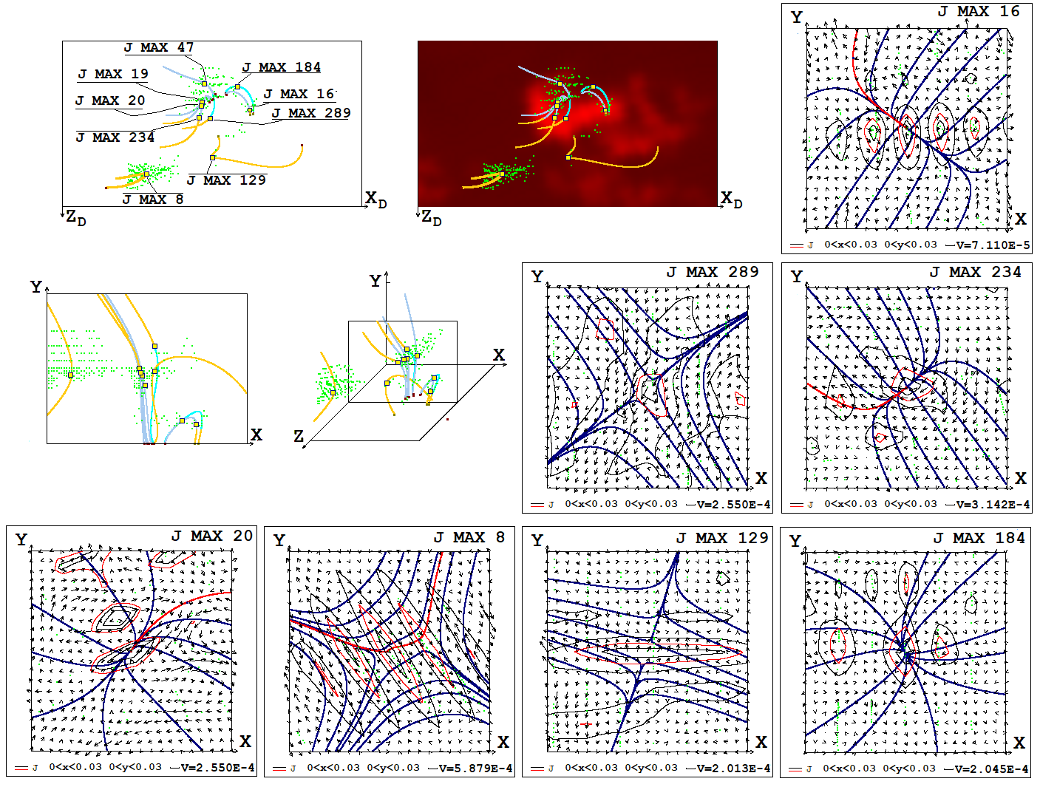
Figure 5. Comparison of the magnetic field configuration and the positions of the current density maxima with the distribution of radio emission intensity at a frequency of 17 GHz on May 26, 2003 at 02:32:05 three hours before the M 1.9 flare for calculation with relatively low viscosities (Re_{m}=10⁹, Re=10⁷). The positions of the current density maxima are shown as green points. The magnetic field configuration is presented by magnetic lines which pass through selected current density maxima with numbers 8, 16, 19, 20, 47, 234, 129, 184, 289. 3D magnetic lines in the computational domain and their projections onto the picture plane and onto the central plane of the computational domain (z=0.5) are shown, as well as in Figure 1. The configurations of plane magnetic lines and plasma flow velocities near the 8th, 16th, 20th, 234th, 129th, 184th and 289th current density maxima are presented.

The magnetic field configurations near the current density maxima, which should be located on singular magnetic lines and are places where the magnetic energy of a solar flare is accumulated, are shown in Figures 2, 3 and 4 for selected maxima.
Figure 5 shows the location of the current density maxima at the time of 02:32:05 on May 6, 2003 for the second calculation variant with low viscosities (Re_{m}=10⁹, Re=10⁷). The magnetic field configuration is represented by magnetic lines passing through the selected 9 maxima, indicated by yellow squares, the remaining current density maxima are indicated by green dots. The configuration of the magnetic field with the positions of the current density maxima in the picture plane is superimposed on the distribution of radio emission intensity at a frequency of 17 GHz. In the vicinity of the seven selected maxima, configurations of the plane magnetic field and plasma flow velocity are presented. More detailed information for some selected maxima is presented in [13].
Field configurations near current density maxima (Fig. 2-5) show that a diverging magnetic field is superimposed on an X-type magnetic field at many current density maxima (see also [12]). In this field superposition, the X-type configuration may predominate, as seen for maxima No.194 in Figure 2, No.12 in Figure 4 and No.8 in Figure 5, resulting in a deformed X-type magnetic field, for which flat magnetic lines have the shape of distorted hyperbolas. Also, the superposition of fields can be dominated by a divergent magnetic field, as for maxima No. 82, 84, 182 and 123 in Figure 3, No. 105 in Figure 4 and №20, 184 in Figure 5, resulting in a deformed divergent magnetic field for which the plane lines of magnetic field are shaped like parabolas. If the influence of the divergent field and the X-type field are equal, then for the superposition of these fields the magnetic lines will have the form of straight lines parallel to one of the coordinate axes, but this is a degenerate case that most likely will not occur in reality. If the influence of the two superimposed configurations is almost the same, then we will get a configuration as for maxima No. 4, 179, 147 and 145 in Figure 2, No. 205 in Figure 3 and No. 26, 234 in Figure 5, in which the divergent magnetic field weakly dominates, or configuration as for maxima No. 73, 41 in Figure 4 and No. 129, 289 in Figure 5, in which the X-type magnetic field weakly predominates. Even if the superposition is dominated by a divergent magnetic field, due to the presence of the X-type field, a fairly powerful current sheet can appear, as can be seen in the field configuration near the maximum current density No. 82 in Figure 3.

Discussion
In order to better understand the difference between the results for the first variant of calculations with high viscosities (Re_{m}=3×10⁴, Re=10⁴), and the second variant, performed for relatively low viscosities (Re_{m}=10⁹, Re=10⁷), we note once again that the Reynolds numbers Re_{m} and Re reflect the predominance of transfer at the Alfven velocity, which is chosen as the dimensionless unit of velocity, over diffusion spreading. It should be noted that the quantities characterizing the actual predominance of transfer with the plasma velocity over the diffusion spreading (Reynolds numbers Re_{mV}=Re_{m}V and Re_{V}=ReV, recalculated to the plasma velocity) are obtained by multiplying Re_{m} and Re by the plasma velocity in dimensionless units. Calculations have shown that near singular lines the velocity of plasma flow, as a result of which a current sheet is formed, in dimensionless units for calculations with the first set of viscosities is V≈10⁻⁶, and for calculations with the second set of viscosities V≈10⁻⁴. The dimensionless parameters characterizing the predominance of real transfer over diffusion for the second variant remain much greater than unity (Re_{mV}≈10⁵ and Re_{V}≈10³), and for the first variant here the principle of limited simulation, strictly speaking, is not fulfilled (Re_{mV}≈0.03 and Re_{V}≈0.01). In this case, despite the predominance of diffusion spreading, some deformation of the field occurs by the flow with a tendency to the formation of a current sheet and the appearance of a maximum current density on a singular line, which makes it possible to determine the expected position of the flare. Most effectively, the formation of a current sheet occurs for the second variant of the calculation, in which the diffusion spreading is significantly weakened compared to the deformation of the magnetic field configuration by the flow (see the current density distribution in the form of a thin sheet for the 129th maximum current density in Figure 5). In addition, the current density at the maxima for the second calculation variant (at the selected maxima j changes from 0.3227 to 0.1072 in dimensionless units, or from 1.927 10⁻⁹ to 6.4 10⁻¹⁰ A/cm2) is 100 - 1000 times higher than the current density at maxima for the first calculation variant (in the selected maxima j changes from 0.1913 10⁻² to .1069 10⁻³, or from 1.142 10⁻¹¹ to 0.638 10⁻¹² A/cm2), however, for the second variant the solution is distorted by the appearance of numerical instabilities. These instabilities appear near the boundary of the computational domain due to difficulties in matching the boundary conditions with the solution within the domain (this is a common problem that arises when developing numerical methods for solving partial differential equations). In the calculation for the second variant of the set of parameters, the grid viscosity corresponding to the Reynolds number, Re_{Grid}, which can be estimated as the product of the plasma velocity in dimensionless units by the spatial step in dimensionless units Vh (in our calculations h = 0.005, therefore Re_{Grid}=2×10⁶), exceeds the specified magnetic and ordinary viscosity (Re_{m}=10⁹, Re=10⁷). Under this condition, the propagation of waves in a plasma with a magnetic field leads to jumps in values from point to point of the spatial grid, which is expressed in the appearance of unreal maxima of the current density at points of the numerical grid near the found maximum, which can be seen in Figure 5 for the 8th, 16th, 20th and 234th maximums. The distortion of the solution due to such jumps in values on the grid for the second calculation variant should increase as a result of disturbances propagating from regions of numerical instabilities near the boundary of the region. For the first calculation variant, the ordinary and magnetic viscosities (Re_{m}=3×10⁴, Re=10⁴) exceed the numerical viscosity (Re_{Grid}=2×10⁸), so that they stabilize the solution, and the current density distribution near the current density maxima is smooth (Figures 2-4).
Let us list some properties that the configuration of the magnetic field should have near the found maximum of the current density, lying on a singular line, so that the position of this maximum is the most likely place in which a flare should occur in the future. A diverging magnetic field, which, by creating a rotational motion around a singular line, prevents the formation of a current sheet, should not significantly dominate the X-type field. The longitudinal magnetic field should not significantly exceed the field of the current sheet, since it prevents the explosive release of energy during a flare. Empirical considerations based on observations indicate that most likely the maximum current density for which a flare can occur should be located at or near the top of the magnetic loop.
As can be seen from Figures 1, 5, a significant part of the current density maxima, which have properties according to which the occurrence of a flare for this maximum has a high probability, is located in the bright radiation region. This confirms the solar flare mechanism, based on the accumulation of energy in the magnetic field of the current sheet. At the same time, for the second calculation variant, quite a lot of maxima with such properties are located at a considerable distance from the bright radiation region. This can be explained by the existence of features of the magnetic field, into which, given changes in the magnetic field at the boundary, sufficiently strong disturbances do not propagate so that current sheets can form there, but such disturbances can propagate from regions where numerical instabilities appear near the boundary of the region.
For the first variant of the calculation, some current density maxima, which have properties at which a flare is likely to appear, also appeared outside the bright region of the flare radiation. This can be explained by some distortion of the solution due to the replacement of partial differential equations with finite-difference ones, although a clearly expressed instability did not appear. However, it should be emphasized that in the first variant of the calculation, in the bright radiation region there are current density maxima, the properties of which best correspond to the appearance of a flare, and maxima with such properties do not appear outside the bright radiation region. First of all, such properties include the appearance of an extended current sheet with a size of several tens of Mm, in which not only the selected current density maximum is located, but the current density maxima located near it, forming a common chain. Examples of such an extended current sheet with several maxima are the configuration near the 4th and 145th maxima, presented in Figure 2; the positions of these maxima are presented in Figure 1. The 147th maximum belongs to the same chain as the 145th maximum. In the second variant of the calculation, chains of maxima also appear, however, due to numerical instabilities and grid effects that appear at low viscosities, the current density distribution breaks up individual maxima, without forming a current sheet, which, apparently, should appear in a real situation. In the first variant of the calculation, extended current sheets with several maxima occur, also outside the region of bright radiation (see, for example, the configuration for the 82nd maximum in Figure 3, its position is indicated in Figure 1). However, in the vicinity of such maxima, a significant diverging magnetic field is superimposed on the X-type field configuration, which can interfere with the formation of a current sheet, causing rotation of the plasma around the axis line. In this configuration, depicted for the 82nd maximum (Fig. 3), located in an extended current sheet outside the bright radiation region, “plane” magnetic lines have the shape of parabolas extending from the point of maximum current density. Only in the bright region of radiation are there maxima of the current density in an extended current sheet with a field configuration in which, near the axis tangent to the magnetic lines at the maximum point, the shapes of the magnetic lines are close to a straight line along this axis (see configurations near the 4th, 145th and 147th maximum in Figure 2). This shape of the lines in the vicinity of the maximum current density means a relatively small influence of the divergent field, which practically does not predominate over the X-type field. It will be necessary to try to use the appearance of configurations with lines close to straight lines along one of the axes in the vicinity of maxima located in the form of chains in an extended current sheet as a precursor for predicting a flare situation obtained from the results of MHD similation. For this purpose, it will also be necessary to carry out further planned modernization of the calculation methodology.
For a more accurate understanding of processes in corona above the active region, it is necessary to improve the method of instability stabilization and carry out calculations for intermediate viscosities. First of all, apparently, it would be best to choose Re_{m}, Re ~ 10⁶ for which the grid viscosity is less than that specified in the calculation, the real Reynolds number (recalculated at the plasma speed near the singularities of the magnetic field) will significantly larger then unity.

Conclusions
1. A technique has been developed for MHD simulation of a flare situation in the solar corona above an active region and for analyzing the results of MHD simulation. The useing metods: an absolutely implicit upwind finite-difference scheme, conservative with respect to the magnetic flux; parallel calculations for the numerical solution of the difference scheme; a method for stabilizing numerical instability that appears near the boundary of the computational domain; graphical system for searching flare positions based on the magnetic field configuration obtained as a result of MHD modeling. The study of processes over the active region is carried out by comparing the results of calculations for relatively small ordinary and magnetic viscosities, at which the disturbance propagating from the solar surface is not suppressed, and large values of viscosity, at which numerical instabilities are stabilized effectively. The results obtained indicate the need for further improvement of the methodology and path of modernization.
2. MHD simulation showed the appearance of current sheets in the found current density maxima located on singular lines, or the deformation of the magnetic field leading to the appearance of current sheets.
3. In the vicinity of the singular lines, a diverging magnetic field can be imposed on the X-type configuration. Even if the divergent magnetic field is dominant such that the superposition results in a deformed divergent magnetic field, due to the presence of X-type configuration of field in the superposition, a current sheet may be formed in the vicinity of such a singular line.
4. Current density maxima are sometimes located in rather long (several tens of Mm) chains. The results of MHD simulation for low viscosities indicate the possibility of the existence of extended current sheets in which the maxima of the chain are located.
5. The location of a large number of current density maxima in the region of bright flare radiation on the solar disk confirms the solar flare mechanism, based on the release of energy accumulated in the magnetic field of the current sheet.
6. The problem of the formation of a significant number of current sheet maxima outside the bright region of flare radiation, with field configuration properties corresponding to the possibility of a flare occurrence, is necessary to be solved by improving the MHD modeling technique.
7. MHD simulation for low viscosities showed that only in the region of bright radiation do extended current sheets appear, containing current density maxima with a configuration in which the shape of the magnetic lines exiting from the maximum point is close to a straight line. The appearance of such extended current sheets only in the region of bright radiation should be used as a precursor of a flare situation obtained as a result of MHD simulation using a technique that is planned to be modernized.

References
1. Lin R.P., Krucker S., Hurford G.J. et al. (2003) Astrophys. J., 595, L69-L76. https://doi.org/10.1086/378932
2. Podgorny, A.I.; Podgorny, I.M.;Meshalkina, N.S. (2015) Astron. Rep. 2015, 59, 795–805. https://doi.org/10.1134/S1063772915080065.
3. Podgorny, I.M.; Podgorny, A.I (2018) Rep.2018, 62, 696–704. https://doi.org/10.1134/S1063772918100074.
4. Podgorny I.M., Podgorny A.I. (2019) Sun and Geosphere. 14(1), 13-76. https://doi.org/10.31401/SunGeo.2019.01.02
5. Syrovatskii, S.I. (1966) Zh. Eksp. Teor. Fiz. 50, 1133–1147.
6. Podgorny, A.I. and Podgorny, I.M. (2012) Geomagn. Aeron. (Engl. Transl.) 52, 150–161. https://doi.org/10.1134/S0016793212020107
7. Podgorny, I.M., Balabin, Y.V., Vashenyuk, E.V., Podgorny, A.I. (2010) Astron. Rep. 54, 645–656. https://doi.org/10.1134/S1063772910070085
8. Podgorny, I.M., Dubinin, E.M., Israilevich, P.L., Nicolaeva, N.S. (1988) Geophys. Res. Lett. 15, 1538–1540. https://agupubs.onlinelibrary.wiley.com/doi/abs/10.1029/GL015i013p01538
9. Podgorny A.I., Podgorny I.M. (2013) Sun and Geosphere. 8(2), 71-76.
10. Podgorny A.I., Podgorny I.M. (2013) Proc. 36 Annual Sem. "Phys. of Auroral Phenomena". Apatity. 117-120.
11. Podgorny A.I., Podgorny I.M., Meshalkina N.S. (2018) JASTP, 180, 16-25 https://doi.org/10.1016/j.jastp.2018.02.009
12. Podgorny, A.I.; Podgorny, I.M.; Borisenko, A.V. (2022) Open Astronomy. 31. 27–37. https://doi.org/10.1515/astro-2022-0006.
13. Podgorny, A.I.; Podgorny, I.M.; Borisenko, A.V. (2023) 2023, 5(3), 895-910. https://doi.org/10.3390/physics5030058
14. Podgorny A.I., Podgorny I.M., Borisenko A.V. (2020) Proc. 43 Annual Seminar "Phys. of Auroral Phenomena", Apatity. 56-59. https://doi.org/10.37614.2588-0039.2020.43.013
15. Podgorny A.I., Podgorny I.M., Borisenko A.V. (2021) Proc. 44 Annual Seminar "Phys. of Auroral Phenomena", Apatity. 92-95. https://doi.org/10.51981/2588-0039.2021.44.021
16. Podgorny A.I., Podgorny I.M., Borisenko A.V. (2022) Proc. 45 Annual Seminar "Phys. of Auroral Phenomena", Apatity. 70-73. https://doi.org/10.51981/2588-0039.2022.45.016
17. Podgorny A.I., Podgorny I.M. (2004) Comput. Math. Math. Phys. 44, 1784-1806.
18. Podgorny I.M. (1978) Simulation studies of Space. Fundamentals of Cosmic Physics. 1, 1-72.

Список авторов с указанием места работы и e-mail, название и аннотация статьи на русском языке

1) Список авторов

Александр Игоревич Подгорный
Физический институт РАН им. П.Н. Лебедева, Москва, Россия. podgorny@lebedev.ru

Игорь Максимович Подгорный
Институт астрономии РАН, Москва, Россия. Был адрес электронной почты: podgorny@inasan.ru

2) Название статьи
Конфигурации магнитного поля в местах солнечных вспышек над активной областью АО 10365 по результатам МГД моделирования

3) Аннотация
Быстрое освобождение магнитной энергии токового слоя в солнечной короне приводит к наблюдаемым проявлениям вспышки, которые объясняются электродинамической моделью вспышки, предложенной И. М. Подгорным. Продолжено исследование механизма солнечной вспышки путем магнитогидродинамического (МГД) моделирования в солнечной короне над реальной активной областью. Для того, чтобы можно было изучить механизм солнечной вспышки, необходимо начинать расчет за несколько дней перед вспышкой, когда в короне еще не накоплена магнитная энергия для солнечной вспышки. Проведены два варианта расчета для сравнительно больших магнитной и обычной вязкостей (Re_{m}=3×10⁴, Re=10⁴) и для относительно малых вязкостей (Re_{m}=10⁹, Re=10⁷). Для МГД моделирования со сравнительно большими вязкостями найдено свойство, которым обладают только те максимумы плотности тока, которые располагаются в яркой области предвспышечного радиоизлучения на частоте 17 ГГц.

